**LAB 09**

**21K-3278 SOHAIB SAROSH SHAMSI**

**Q1.**

Include Irvine32.inc

.data

prompt1 byte "Enter number to multiply with 21: ";

NUM dword ?

ans dword ?

.code

main proc

mov edx, offset prompt1

call writestring

call readint

mov NUM, eax

;21 = 2^4 + 2^2 + 2^0

mov ecx, NUM

mov ebx, NUM

shl eax, 4

shl ebx, 2

shl ecx, 0

mov ans, eax

add ans, ebx

add ans, ecx

mov eax, ans

call writedec

exit

main endp

end main

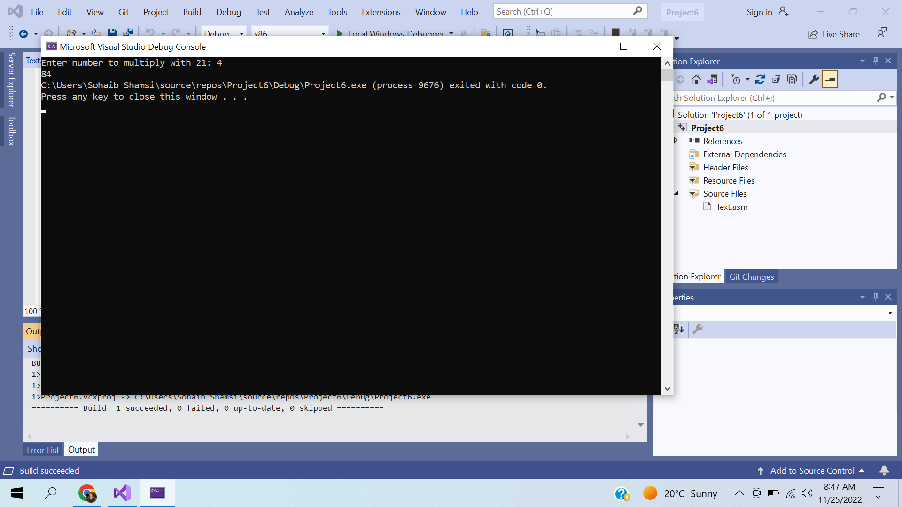

**Q2.**

Include Irvine32.inc

.data

.code

main proc

mov ax, -128

rol eax,16

sar eax,16

call writehex

exit

main endp

end main

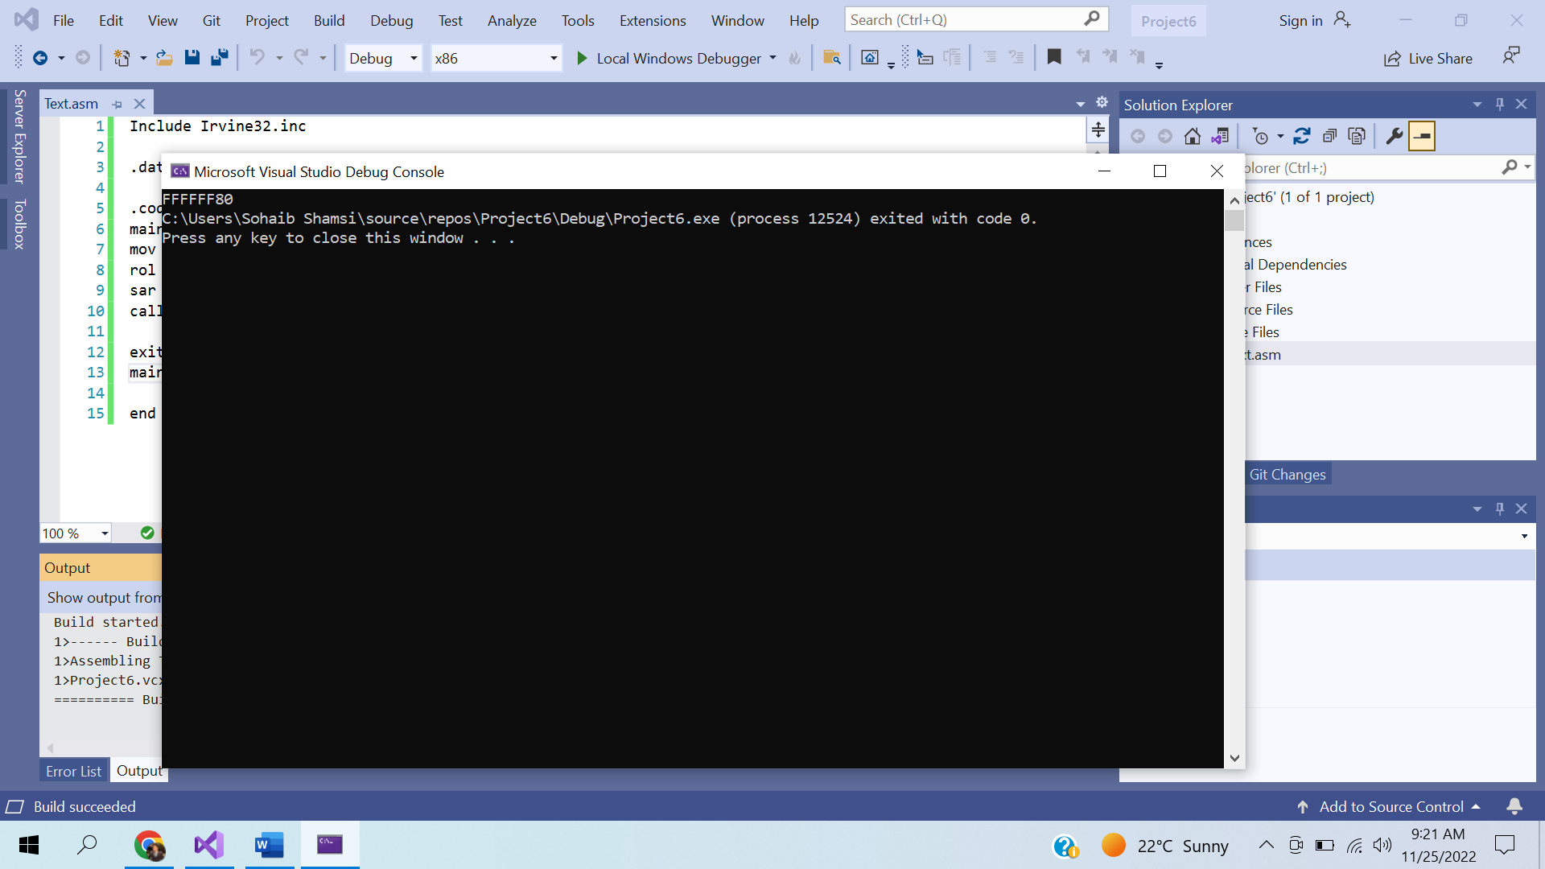

**Q3.**

Include Irvine32.inc

.data

bMinutes byte ?

.code

main proc

mov bx,111010111001111b ;Seconds = 01111 ; Minutes = 01110 ; Hours = 11101

shr bx, 5

and bl,00011111b

mov ax, bx

mov bMinutes, al

movzx eax, bMinutes

call writebin

exit

main endp

end main

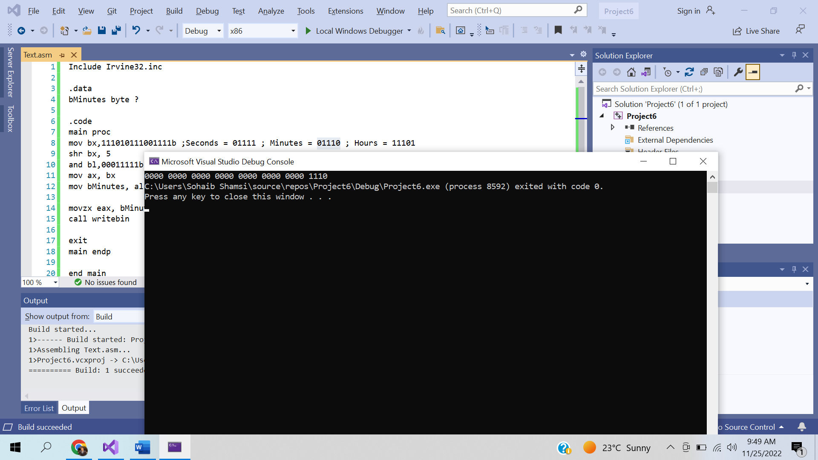

**Q4.**

Include Irvine32.inc

.data

prompt1 byte "Using SHRD: ",0

.code

main proc

mov bx,1111010111001111b

mov eax, 0

mov ax,0000000000000001b

rcl ax, 15

shr bx, 1

or bx, ax

movzx eax, bx

call writebin

call crlf

mov edx, offset prompt1

call writestring

call crlf

mov bx,1111010111001111b

mov eax, 0

mov ax,0000000000000001b

shrd bx, ax, 1

movzx eax, bx

call writebin

exit

main endp

end main

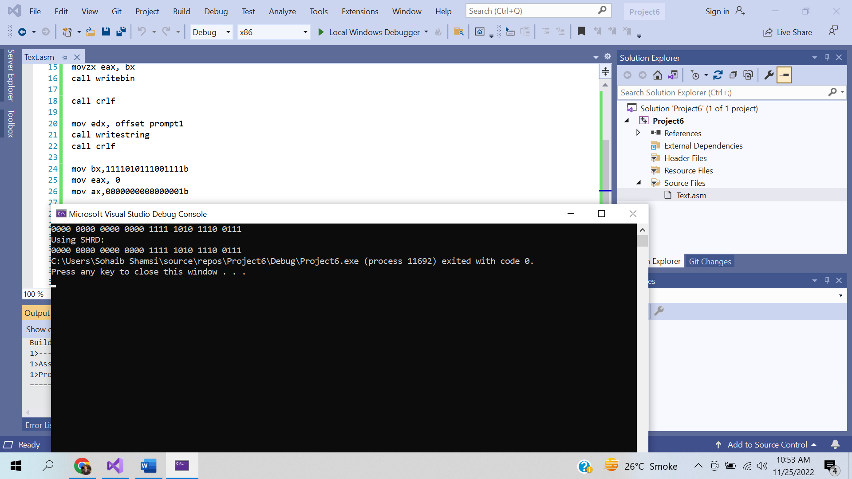

**Q5.**

INCLUDE irvine32.inc

INCLUDE macros.inc

.data

Val1 SDWORD ?

Val2 SDWORD ?

Val3 SDWORD ?

ans1 SDWORD ?

ans2 SDWORD ?

.code

MAIN PROC

mov eax,0

mWrite "Enter value 1: "

call ReadInt

mov Val1,eax

mWrite "Enter value 2: "

call ReadInt

mov Val2,eax

mWrite "Enter value 3: "

call ReadInt

mov Val3,eax

mov eax,Val2

CDQ

idiv Val3 ; Val2 / Val3

mov ans1,eax

mov eax,val1

CDQ

idiv Val2 ; Val1 / Val2

mov ans2,eax

mov eax,ans1

mov ebx,ans2

imul ebx ;ans1 * ans2

mWrite "Answer: "

call WriteInt

exit

MAIN ENDP

END MAIN

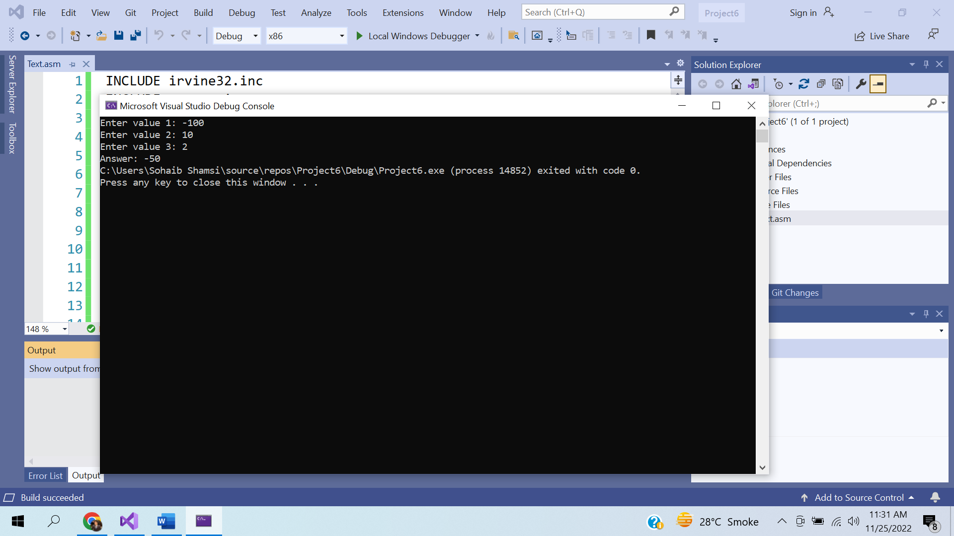

**Q6.**

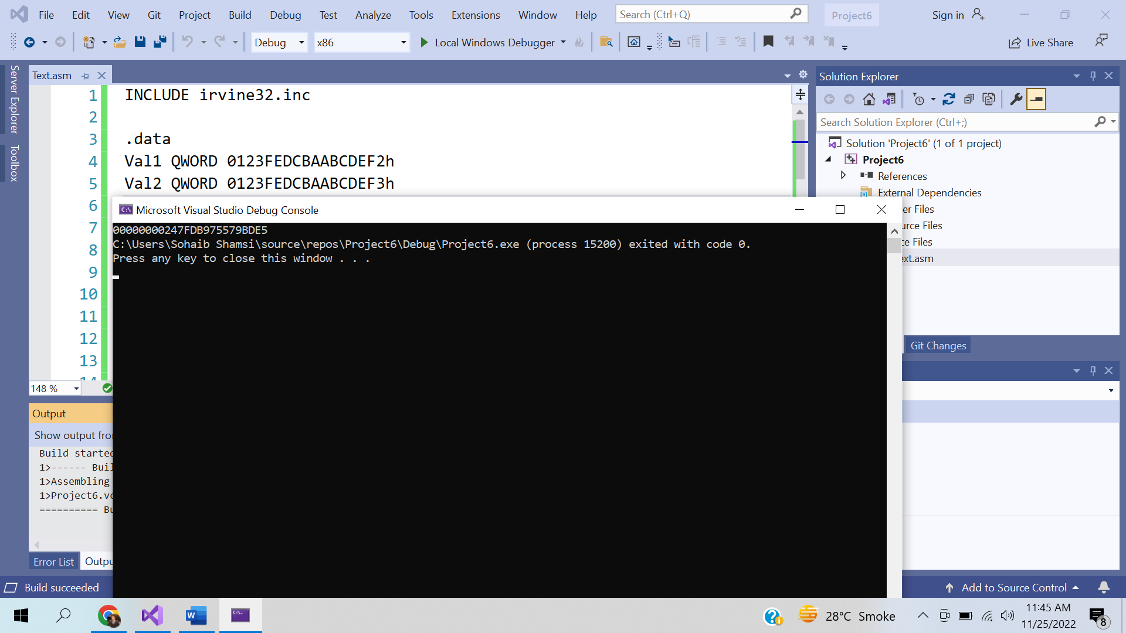

INCLUDE irvine32.inc

.data

Val1 QWORD 0123FEDCBAABCDEF2h

Val2 QWORD 0123FEDCBAABCDEF3h

ans DWORD 3 DUP(?)

.code

MAIN PROC

mov esi,OFFSET Val1

mov edi,OFFSET Val2

mov ebx,OFFSET ans

mov ecx,2

call Extended_Add

mov eax,DWORD PTR ans + 8

call WriteHex

mov eax,DWORD PTR ans + 4

call WriteHex

mov eax,DWORD PTR ans

call WriteHex

exit

MAIN ENDP

Extended_Add PROC

pushad

clc

LoopTime:

mov eax,[esi]

adc eax,[edi]

pushfd

mov [ebx],eax

add esi,4

add edi,4

add ebx,4

popfd

loop LoopTime

adc WORD PTR [ebx],0

popad

ret

Extended_Add ENDP

END MAIN